Nathan Christiansen

Block 2 Project Proposal

My project proposal is for my own weather app called The Reigning Weather App. The purpose of the Reigning Weather App is to provide the user with a weather app that can search the weather based on city. The search will find a city and use the Open Weather Map API. Once searched, the city will be added to the main page display. The localStorage will be utilized to pull up the past searched locations and display them. There will be an option to delete the cities from the list as well.

The audience of this project is anyone looking for a simple weather app which displays the necessary information regarding weather in the area. The ease of use will benefit anyone who’s old enough to get on the computer, or phone and know how to spell a city.

The data source will be the Open Weather Map API and localStorage.

My initial modules will include a search form that once searched, a card will be created which displays the city and weather information. They can continue to search cities and add them to their list.

Above is a wireframe of the site including 3 previously searched locations included on cards.

For typography I have decided to use the Kanit Font which appears like this (Welcome to the Reigning Weather App)

My color scheme I have decided to follow a royal theme which appears below

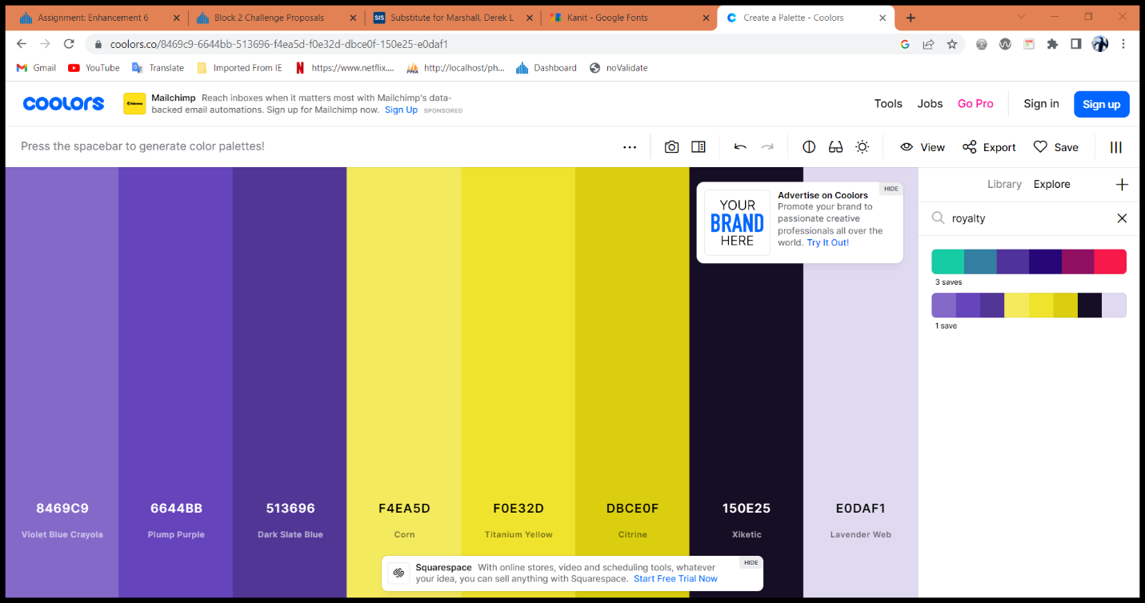

Once I begin the project, I plan to spend at least an hour a day Monday through Friday working on this assignment. My schedule is included on my To-Do List Below

